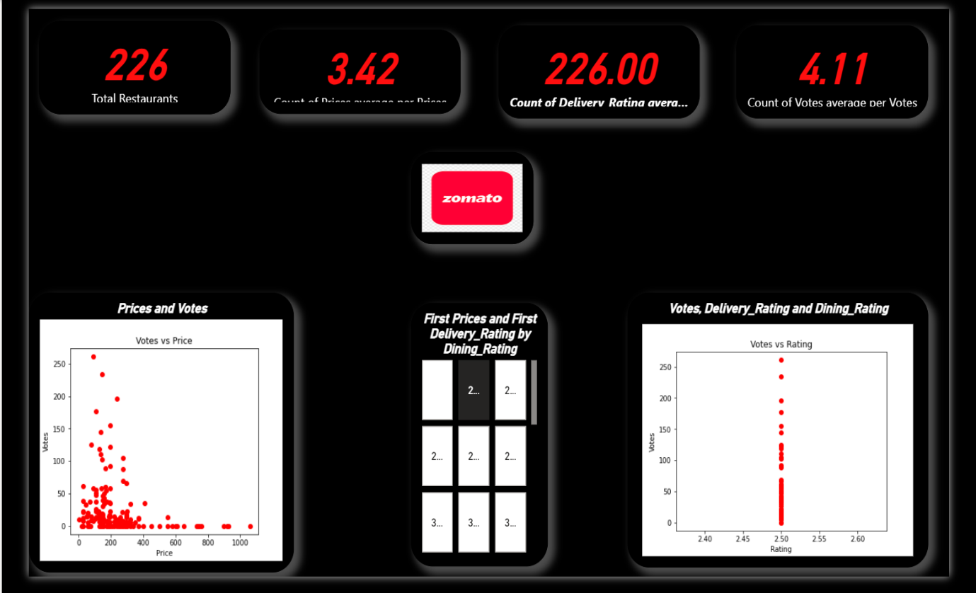
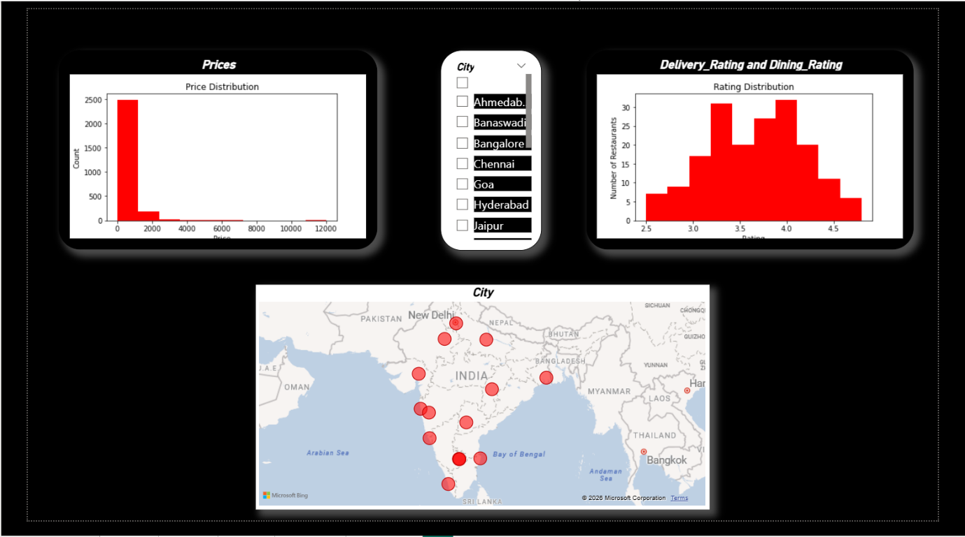

SUMMARIZATION
This project Analys restaurant performance data to understand customer behaviour pricing trends, and rating patterns. Using Power BI with Python integration, the dashboard converts raw data into meaningful insights that help businesses make data-driven decisions related to pricing, quality, and customer engagement.
KEY INSIGHTS
The main goals of this project are to:
- Analyze restaurant performance using key metrics
- Identify customer preferences based on price, ratings, and votes
- Discover patterns that influence customer engagement
- Present insights through a clean, interactive Power BI dashboard

BUSINESS RECOMMENDATIONS
- Optimize menu prices within the most popular price band
- Introduce combo meals or value deals
- Improve food quality, hygiene, and service consistency
- Actively respond to customer feedback and reviews
- Train staff to enhance customer experience

FINAL DASHBOARD STORY
This dashboard tells the complete story of how pricing and quality influence customer engagement in restaurants.
At a high level, the KPIs show a market with a large number of restaurants, stable average ratings, and strong customer participation through votes. This indicates a competitive environment where customers actively evaluate and compare options.
As we move into the visual analysis, the rating distribution reveals that most restaurants maintain ratings between 3.5 and 4.5, suggesting consistent service quality across the market. The price distribution shows that the majority of restaurants fall into the mid-price range, highlighting affordability as a key factor for customers.

Four types of Analysis

Descriptive Analysis
- Most restaurants fall within the ₹150–₹300 price range
- Ratings are largely concentrated between 3.5 and 4.5
- A small number of restaurants receive very high votes, indicating popularity bias
Diagnostic Analysis
- Restaurants with mid-range prices receive higher votes
- Higher ratings strongly correlate with increased customer engagement
- Expensive restaurants do not necessarily attract more votes

Predictive Analysis
- Restaurants priced between ₹150–₹300 and rated above 4.0 are likely to gain higher votes
- Poorly rated restaurants may struggle to attract customers
- Trend-based analysis using existing price, rating, and vote patterns

Prescriptive Analysis
- New restaurants should adopt mid-range pricing
- Focus on improving service quality to maintain high ratings
- Platforms should promote top-rated restaurants
- Avoid overpricing unless offering premium value

